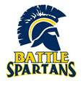
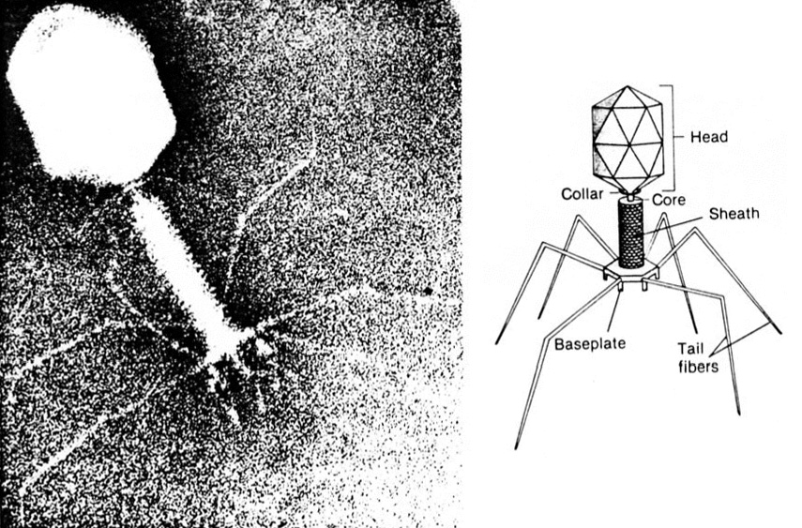

Microbiology & Disease

What is it?
(Grades: 11-12 Credit: 1/2 Biological or Elective Science)
Prequisite: Biology
Recommendation: C or higher grade in Biology

This class will explore the diversity of microbiology including viruses, bacteria, fungi, and other Eukaryotic parasites. We will not only study the basic biology of each microbe group, but we will also use a hands-on approach (laboratories) to teach the skills and principles of how to safely perform research with microbes. Finally we will study how each of these microbes can cause disease in each other, plants, and animals (most importantly humans). Our emphasis will be the pathology and epidemiology of the disease causing organisms.

Who should take it?
Did you enjoy the lab portions of biology?
Is veterinarian science or a health care profession in your future?
Do you like seeing what gross things microbes can do to other organisms (especially humans)?
Are you intrigued by how diseases are spread, cured, or prevented?

What are the expectations?
This is an upper level science class. You must take notes, study, think, and memorize.
You will maintain a science notebook with pictures, notes, colorings and lab activities.
You will often work with a group for class activities and labs.

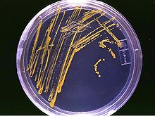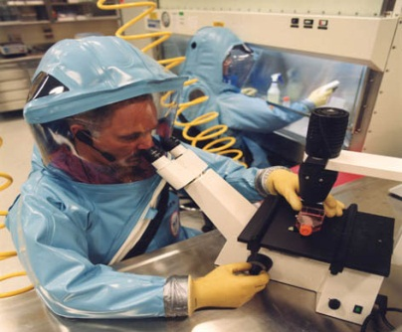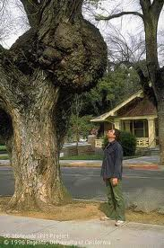
What will you study?

Units | Major Activities
Epidemiology | Disease spread simulation  Sterile technique  Case Studies
Viruses | Plant Inoculation  HIV Mutation  Vaccinations
Bacteria | Gram Stain  Unknown Mystery  Food Safety
Protists | What’s in the Water  Water Contamination  The Trouble with Run Off
Other Eukaryotic Microbes | Monsters Inside Me  Koch’s Postulates  Historical Outbreaks

