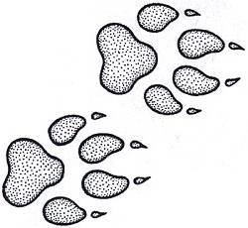

Zoology
What is it?
(Grades: 11-12; Credit: ½; Type: Biological or Elective Science)
Prerequisite: Biology
Recommendation: C or higher grade in Biology

This class will explore the animal kingdom from simple sponges to complex mammals. We will see how animals have developed different strategies for survival. The dissection of representative animals will help us learn about different anatomy. We will discover the relationships between different taxonomic categories of animals. The impact of different animals on people and each other will be revealed. An emphasis will be placed on laboratory skills, keeping an organized notebook and working together.

Who should take it?
Did you enjoy the lab portions of biology?
Is veterinarian science, marine biology or conservation in your future?
Do you like critters?
Are you intrigued by dissection?
Is animal planet your favorite channel?

What are the expectations?
This is an upper level science class. You must take notes, study and memorize.
You will maintain a science notebook with pictures, notes, colorings and lab activities.
You will work with a group for class activities, labs and dissections.

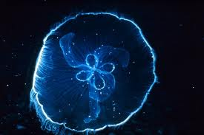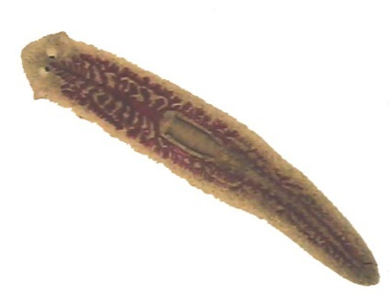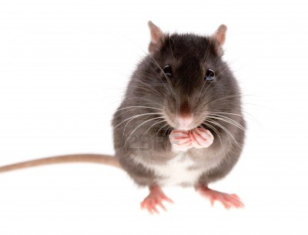
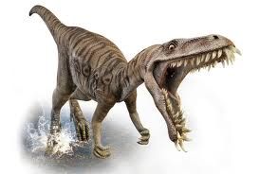
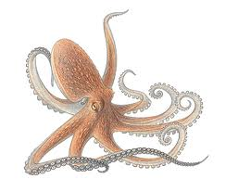
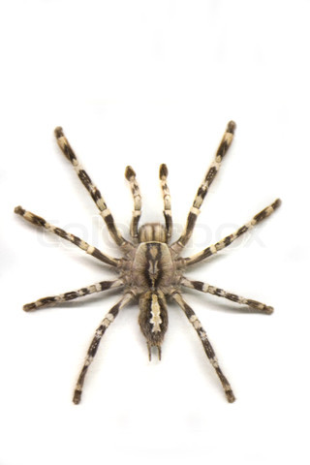

What will you study?

For each group of organisms studied, you will be asked to
- Classify taxonomically
- Describe evolutionarily significant adaptations
- Explain organs and functions used in life processes

Units | Major Activities
Sponges and Cnidarians | Planarian  Zebra fish
Worms and Mollusks | Dissect Earthworm  Dissect Clam  Dissect Squid
Arthropods and Echinoderms | Dissect Crayfish  Dissect Grasshopper  Dissect Sea Star
Chordates and  Ectotherms | Dissect Fish  Dissect Frog
Endotherms | Great Fossil Find  Walking with Dinosaurs  Dissect Rat

