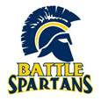
BIOLOGY

What is it?
(Grades: 10; Credit: 1; Type: Biological Science)
Prerequisite: Physics 1
Honors Recommendation: Approval from 9th grade science teacher

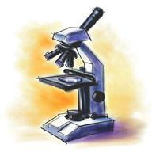
Biology is a course that explores the topics of cellular biology, genetics, life processes, and ecological relationships. Along with an understanding of broad biological concepts and principles, an emphasis is placed on personal needs and societal issues. Lab activities stress thinking, inquiry and process skills.
Who should take it?
- This is a required course for ALL
students.
- This is a prerequisite course for
many other science electives.

What are the expectations?
This is a life science which provides the foundational understanding for all other life science electives. Students will be expected to take effective notes, study outside of class and be able to apply knowledge to new situations. Students will maintain a science notebook which will act as your reference for the course. Collaboration is expected on many activities.

Honors vs. General?
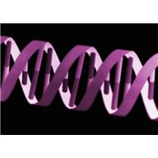
Honors Biology explores the same fundamental biological concepts as Biology. However, it requires a more detailed and in-depth analysis of selected biological concepts. The course provides more opportunities for long-term assignments and projects. Intensive writing and reading assignments require students possess above average language and critical thinking skills.

What will you study?

Theme | Topics | Labs/ Activites
Semester One
What is living? | Characteristics of life  Levels of organization  Cells (intro.) | Living, nonliving, dead lab  Soybean plants  Microscopes
Body balance and Disease | Homeostasis  Cell membrane  Water  Cell size | Osmosis lab  Joe cell  Gel Cell Races
Cloning and Cancer | DNA  mitosis | Strawberry DNA extraction  DNA fingerprint
Stem cells | Karyotypes  meiosis | Planaria lab
Mutations  Human/ agricultural variation | Protein synthesis  Genetics  Biotechnology | Brassica lab
Semester Two
Energy through the ecosystem | Food chains  food webs  energy pyramids | African safari
Energy through the organism | Atoms, molecules and bonds  Photosynthesis  Cellular respiration | Fuel cell demonstration  Chromatography  Burning food lab
Matter (nutrition and disease) | Nutrient cycles  Macromolecules  Enzymes | Soybean plant data  Food label  Liver lab
Human Impact | Population ecology  biodiversity | Deer game  Something for everyone  Most wanted posters
End of Course Exam
Nature around you | Classification | Boone county organisms  Jelly belly key

