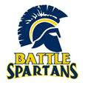
CHEMISTRY
What is it?
(Grades: 11 & 12; Credit: 1; Type: Elective Science)
Prerequisites: See math recommendations below
- General Recommendation: Math and Science teacher approval and “C” or better in Algebra 1
- Honors Recommendation: Math and Science teacher approval and “B” or better in Geometry
Chemistry, taught using the Modeling Instruction approach, emphasizes the construction and application of conceptual models. Students develop particle models that evolve from unit to unit to construct their own understanding of matter and the role of energy in physical and chemical changes. Traditional chemistry concepts including gas properties, structure of matter, chemical equations and chemical reactions are investigated using the graphical analysis of laboratory data and other technologies.
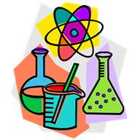
Who should take it?
- Did you enjoy the lab portions of science?
- Are you interested in how society is affected by chemistry?
- Did you play with that chemistry kit in grade school?
- Do you like logic puzzles?

What are the expectations?
This is an upper level science class. You will be expected to take effective notes, study outside of class and be able to apply knowledge to new situations. You will organize your own materials to serve as reference throughout the class. Collaboration is expected on many activities.

Honors vs. General?
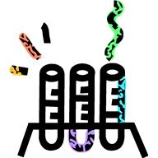
Honors Chemistry develops the unifying concepts and principles of chemistry using evidence based models from an “outside in” approach, using technology and laboratory experiences. Emphasis is placed on developing problem solving skills, synthesizing information, and communicating results while working in teams. The same content found in General Chemistry will be developed in greater depth and additional topics will be investigated. The Science & Engineering Practices in the Next Generation Science Standards (NGSS) are embedded in this course designed for students planning to pursue a course of study that will involve additional science courses at the high school and college levels. Honors chemistry is recommended for any students wanting to pursue pharmacy school, veterinary medicine, medical school, chemical engineering, or a chemistry degree. Students will be prepared to take the next level of chemistry, AP Chemistry.

