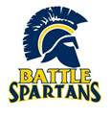
HUMAN ANATOMY & PHYSIOLOGY

What is it?
(Grades: 11 & 12; Credit: 1; Type: Elective Science)
Prerequisite: Biology, Physics 9 & Chemistry
General Recommendation: C or higher grade in Biology for General Course
Honors Recommendation: A in Biology or B or higher grade in Honors Biology for Honors Course

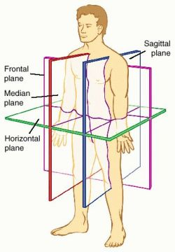
This course is designed to meet the needs of those students interested in learning more about the structure and function of the human body. In addition to studying the basic anatomy of each organ system, students will spend considerable time in activities oriented toward a better understanding of the physiology or functioning of each system. The focus of study will be on the skeletal, muscular, nervous, cardiovascular, digestive, respiratory, and urinary systems, with the emphasis on the principles of nutrition, fitness, and disease prevention. Dissection is a required part of the course. A fetal pig will be dissected in order to enhance the comprehension of the organs and structures studied.

Who should take it?
- Did you enjoy the lab portions of biology?
- Are you seeking a career in veterinary medicine,
medicine or nursing?
- Are you intrigued by dissection?
- Is House your favorite TV show?
What are the expectations?
This is an upper level science class. You will be expected to take effective notes, study outside of class and be able to apply knowledge to new situations. You will maintain a science notebook which will act as your reference for the course. Collaboration is expected on many activities.

Honors vs. General?
The Honors course is especially targeted toward students with a definite interest in pursuing a medical or health-related career and so uses a more clinical approach. Though the same concepts are covered as the General course, the concepts are dealt with in greater depth and detail. Less in-class time is devoted to practice and review: Students are expected to practice the information on their own time. Supplementary readings, in-class projects, guest speakers and field trips (funding dependent) are included in the Honors curriculum to expose students to a wide variety of health care careers.
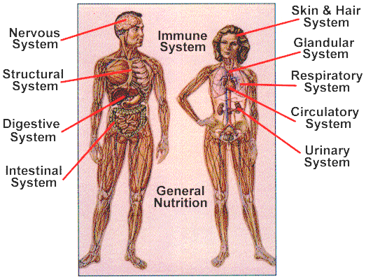
What will you study?
For each human body system studied, you will be asked to:
- Describe the system in terms of structures and functions
- Describe how the system helps the human body maintain homeostasis
- Identify medical conditions/ disorders associated with the system

Curriculum | Major Activities
1st semester
- Introduction anatomy: medical and anatomical terminology  - Body planes and directional terms  - Homeostasis and hydration  - Human Cell Biology  - Immune System  - Human Tissues and Integumentary System  - Skeletal System  - Muscular System | - Medical Terminology quizzes  - Skeletal Practical Exam  - Forensic Anthropology activity  - Optional cat dissection, musculature  - Problem-Based Learning Assessments
2nd semester
- Nervous System  - Digestive System  - Circulatory System  - Blood  - Heart and major vessels  - Respiratory System  - Urinary System  - Reproductive System  - (Endocrine System—incorporated throughout) | - Pig Dissection  - External and internal anatomy  - Digestive  - Blood vessels/ heart  - Respiratory  - Urogenital  - Pig Practical Exam  - Problem-Based Learning Assessments
